Order Of Service

Singing: Psalm 73—CW page 94

Reading: Psalm 135

Opening Hymn: TLH 2

Reading: James 4:1-10

Request Hymn: CW Supplement 702

Reading: Luke 19:45-48

Sermon Hymn: TLH 657

Sermon Text: Song of Solomon 2:1

A Rose & A Lily

Prayer

The Apostles’ Creed, TLH page 12

Holy Communion

The Lord's Prayer

The Blessing

Closing Hymn: TLH 47

* * * * * * * * * * *

Bible Study: Lambs: Daniel 3; I Peter 4:12; Fiery Trial
Sheep: Proverbs 5:20-23; Your Choice
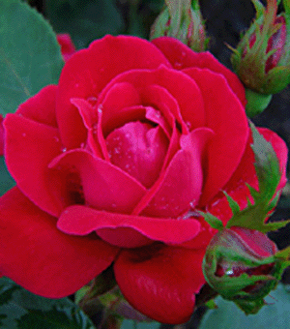

Water
Of
Life
18 October 2015

W A T E R O F L I F E

Independent Christian Church—Conservative Lutheran Doctrine

Worship Service: 9:30 a.m. Bible Study: 10:45 a.m.

Larry Cooper, Pastor E-Mail address:
111 N. Ridge Road lcooper@wateroflife.cc
Coon Valley, WI 54623 Web Site:
Phone: (608) 452-2105 www.wateroflife.cc

* * * * * * * * * * * * * * * * * * * * * * * * * * *

Sermon Text: Song Of Solomon 2:1

A Rose & A Lily

* * * * * * * * * * * * * * * * * * * * * * * * * * *

1. I AM the rose of Sharon, and the lily of the valleys.

As I See It—

Chapter two of Song of Solomon brings us to a new beginning. We could perhaps say that the Bride is taken away from her beautiful home in the new heaven and new earth, and is brought back into that great and terrible wilderness. In verse 2 of this second chapter we find her compared by her Bridegroom to a “lily among thorns.” And this guides us back to Genesis 3:17-18—“Cursed is the ground for thy sake; . . . thorns also and thistles shall it bring forth to thee.” (Different Hebrews words for “thistle”, but we still get the picture.)

There is a disagreement among commentators as to just who is speaking in verse 1 of this chapter. Some say the Bridegroom is speaking. Others say it is the Bride doing the talking. It could be either one. In my opinion it is the Bridegroom doing the speaking. I’ll give my reasons for this in the sermon.

It seems, then, that the chapter can be looked at in this way:
Verse 1--The Bridegroom speaks of himself.
Verse 2—The Bridegroom speaks of his Bride.
Verses 3-17--The Bride speaks about her Bridegroom.

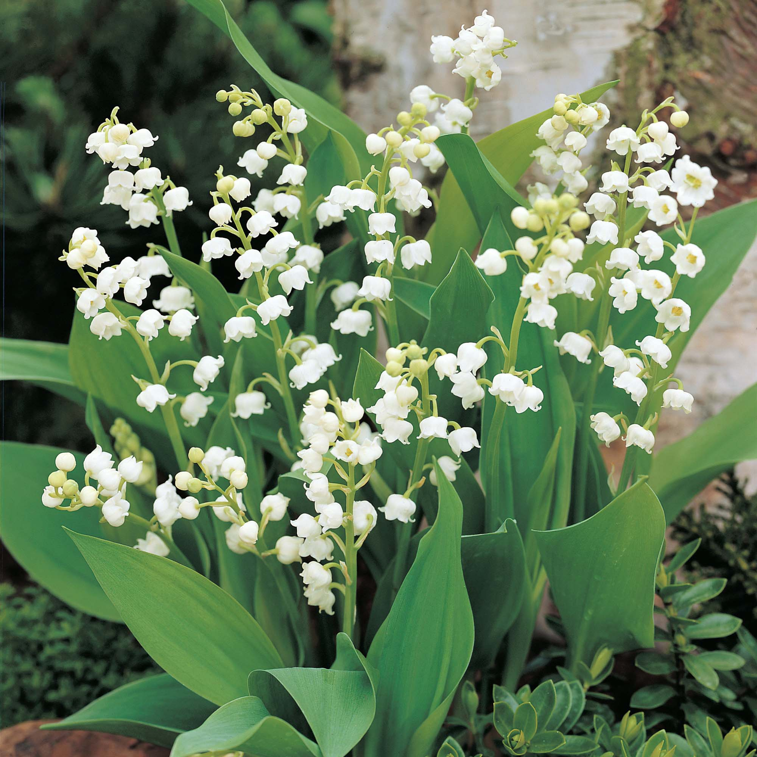

Lily of the Valleys

